Lab#8
Working with SQLite Database using Python

Name: Shehroz Ahmad
Roll NO:- 9362

Lab Exercises
Task 1: Basic Operations
1. Create a new database called library.db
2. Create a table called books with columns: id, title, author, year, available (boolean)
3. Insert 5 books into the table
4. Retrieve and print all books

import sqlite3
connection = sqlite3.connect('library.db')
cursor = connection.cursor()

cursor.execute('''
CREATE TABLE IF NOT EXISTS books (
id INTEGER PRIMARY KEY AUTOINCREMENT,
title TEXT NOT NULL,
author TEXT,
year INTEGER,
available BOOLEAN
)
''')
connection.commit()
books = [
("The Alchemist", "Paulo Coelho", 1988, True),
("Atomic Habits", "James Clear", 2018, True),
("1984", "George Orwell", 1949, False),
("The Silent Patient", "Alex Michaelides", 2019, True),
("To Kill a Mockingbird", "Harper Lee", 1960, False)
]
cursor.executemany("INSERT INTO books (title, author, year, available) VALUES (?, ?, ?, ?)", books)
connection.commit()
cursor.execute("SELECT * FROM books")
for b in cursor.fetchall():
print(b)
connection.close()
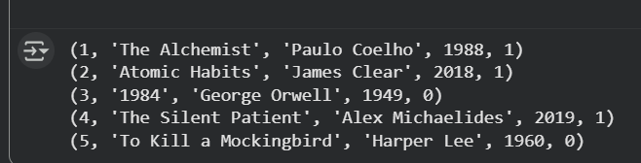
Task 2: Queries
1. Find all books published after 2010
2. Count how many books are available 3. List all unique authors

import sqlite3

connection = sqlite3.connect('library.db')
cursor = connection.cursor()

cursor.execute("SELECT * FROM books WHERE year > 2010")
print("Books after 2010:")
for b in cursor.fetchall():
print(b)

cursor.execute("SELECT COUNT(*) FROM books WHERE available = 1")
print("\nAvailable books:", cursor.fetchone()[0])

cursor.execute("SELECT DISTINCT author FROM books")
print("\nUnique authors:")
for a in cursor.fetchall():
print(a[0])

connection.close()
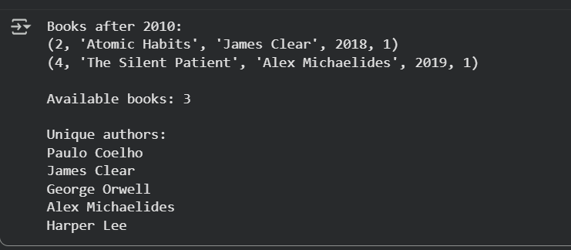
Task 3: Updates and Deletes
1. Update a book's availability status
2. Delete books older than 1950
3. Update all books by a specific author to mark them as unavailable

import sqlite3

connection = sqlite3.connect('library.db')
cursor = connection.cursor()
cursor.execute("UPDATE books SET available = 0 WHERE title = 'Atomic Habits'")
connection.commit()
cursor.execute("DELETE FROM books WHERE year < 1950")
connection.commit()

cursor.execute("UPDATE books SET available = 0 WHERE author = 'Harper Lee'")
connection.commit()
cursor.execute("SELECT * FROM books")
for b in cursor.fetchall():
print(b)
connection.close()
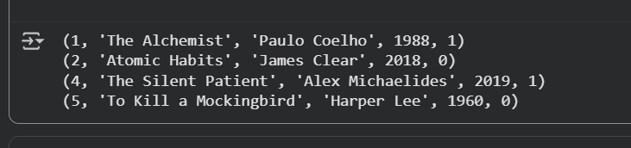

Task 4: File Operations
1. Export your books table to a CSV file
2. Create a new table borrowed_books
3. Write a function that moves a book from books to borrowed_books

import sqlite3
import csv

connection = sqlite3.connect('library.db')
cursor = connection.cursor()

cursor.execute("SELECT * FROM books")
data = cursor.fetchall()
column_names = [d[0] for d in cursor.description]

with open('books_export.csv', 'w', newline='') as f:
writer = csv.writer(f)
writer.writerow(column_names)
writer.writerows(data)

cursor.execute('''
CREATE TABLE IF NOT EXISTS borrowed_books (
id INTEGER PRIMARY KEY AUTOINCREMENT,
title TEXT,
author TEXT,
year INTEGER,
available BOOLEAN
)
''')
connection.commit()

def borrow_book(book_id):
cursor.execute("SELECT * FROM books WHERE id = ?", (book_id,))
book = cursor.fetchone()
if book:
cursor.execute("INSERT INTO borrowed_books (title, author, year, available) VALUES (?, ?, ?, ?)",
(book[1], book[2], book[3], False))
cursor.execute("DELETE FROM books WHERE id = ?", (book_id,))
connection.commit()
print(f"Book ID {book_id} moved to borrowed_books")

borrow_book(2)

print("Remaining books:")
cursor.execute("SELECT * FROM books")
for b in cursor.fetchall():
print(b)

print("\nBorrowed books:")
cursor.execute("SELECT * FROM borrowed_books")
for b in cursor.fetchall():
print(b)

connection.close()
